

SEQUENCE DIAGRAM – MODULE 2

**Version1.0**

**Nhan Pham**

**01/03/2020**

**VERSION HISTORY**

|  |  |  |  |  |  |
| --- | --- | --- | --- | --- | --- |
| **Version #** | **Implemented**  **By** | **Revision**  **Date** | **Approved**  **By** | **Approval**  **Date** | **Reason** |
| 1.0 | Nhan Pham | 01/03/2020 |  |  | Create document sequence diagram v1.0 |
|  |  |  |  |  |  |
|  |  |  |  |  |  |
|  |  |  |  |  |  |

Table of Contents

1. Introduction 3

1.1 Goal 3

1.2 Execute team 3

1.2 Reader 3

2. SEQUENCE DIAGRAM 3

**2.1. View Project App 5**

**2.2. View list ongoing projects app 6**

**2.3. View list deploying projects app 5**

**2.4. View List has deployed Projects App 6**

**2.5. View detail projects app 7**

**2.6. View project website 7**

**2.7. Add project website 8**

**2.8. Edit project website 9**

# 

# Introduction

## Goal

The goal of this document is to design the Sequence Diagram for BDS project

## **Execute team**

|  |  |
| --- | --- |
| **Full name** | **Role** |
| Huỳnh Tuấn Đạt | Leader |
| Trịnh Thị Như Phương | Member |
| Nguyễn Anh Minh | Member |
| Trương Quang Vương | Member |
| Phạm Quốc Nhân | Member |

## **Reader**

|  |  |
| --- | --- |
| **Reader** | **Content** |
| Đặng Đình Hòa | 1, 2, 3 |
| Team | 1, 2, 3 |

# Sequence Diagram

**2.1. View Project App**

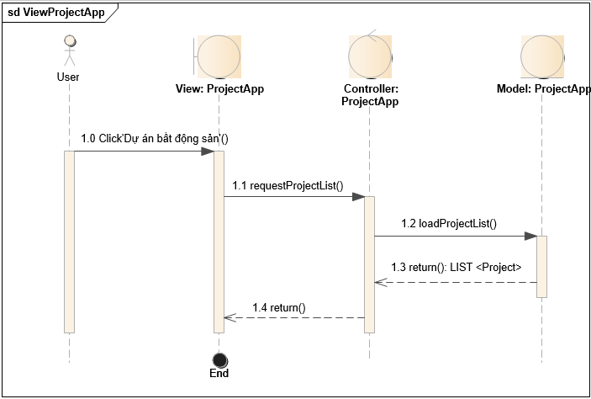

**2.2. View list ongoing projects app**

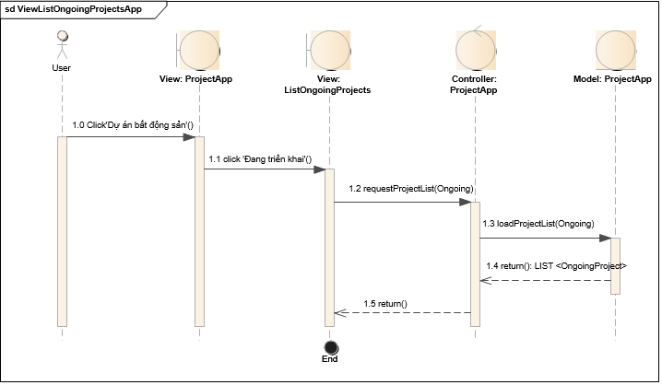

**2.3. View list deploying projects app**

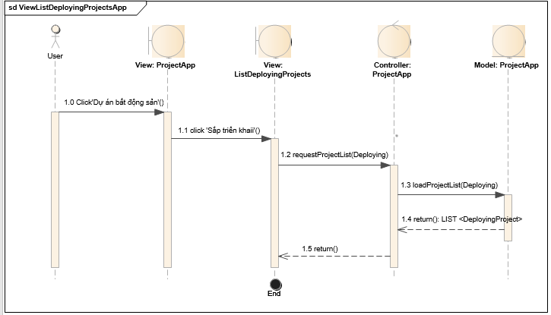

**2.4. View List has deployed Projects App**

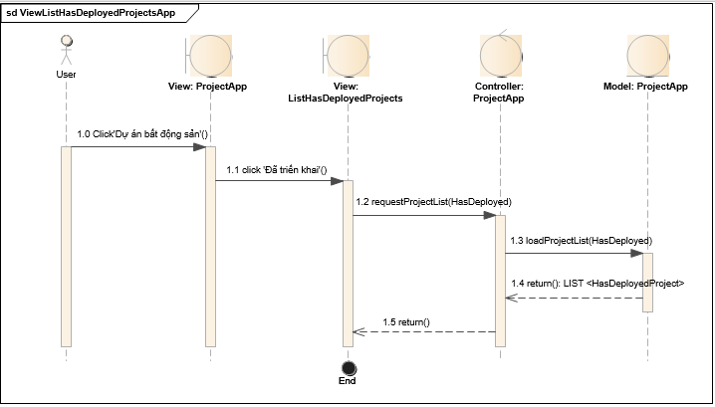

**2.5. View detail projects app**

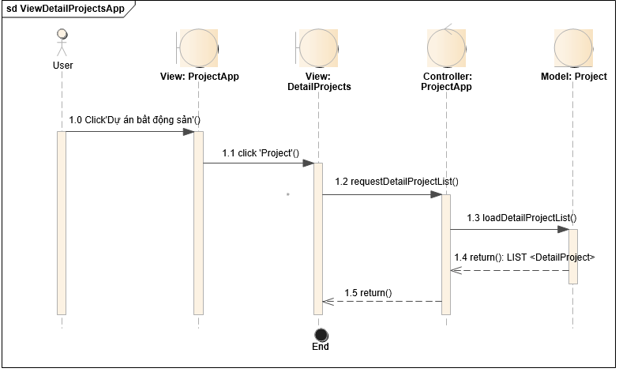

**2.6. View project website**



**2.7. Add project website**



**2.8. Edit project website**

